Imperialism Source Packet

Source #1: Cecil Rhodes quotation

Background: Cecil Rhodes was a famous British imperialist.
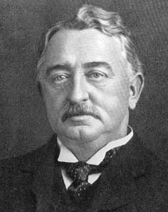

“We must find new lands from which we can easily obtain raw materials and at the same time exploit the cheap slave labour that is available from the natives of the colonies. The colonies would also provide a dumping ground for the surplus goods produced in our factories.”

Review Questions:
- According to Rhodes, why should the British find new lands?

- Once they find these new lands, what will the Europeans do to these lands and the people living there?

- What does Rhodes want to do with the extra goods produced in British factories? Does he actually want to throw them away?

- How does this quote describe the causes of imperialism?

Source #2: Cartoon of the White Man’s Burden

Background: The White Man’s Burden was an idea that helped cause imperialism. Whites (Europeans and Americans) non-whites (Africans, Indians, and other Asians) were uncivilised. The White Man’s Burden was the idea that whites had a responsibility to civilise the non-whites. To do this, the whites would have to teach them their religion, language, and ideas about politics and economics. According to the Europeans, this was a reason to imperialise Africans and Indians.

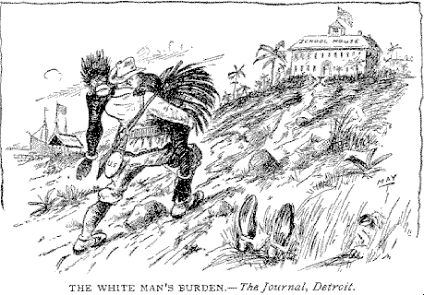

- The image describes TWO people: a white soldier and a native. The soldier is carrying the native. Why is a soldier carrying the native? What does this say about imperialism?

- Where is the soldier taking the native?

- What will the native learn there?

- How does this relate to the White Man’s Burden?

Source #3: Cartoon of the Scramble for Africa

Background: The Scramble for Africa was the competition for land in Africa between European countries. The Industrial Revolution spread to other European countries during the 1800s. These countries started to need more natural resources for their factories and decided to imperialise Africa to get them. They competed for land in Africa because they wanted as many natural resources for themselves as possible. They didn’t want other countries to get them. This created rivalries between some of the European countries.
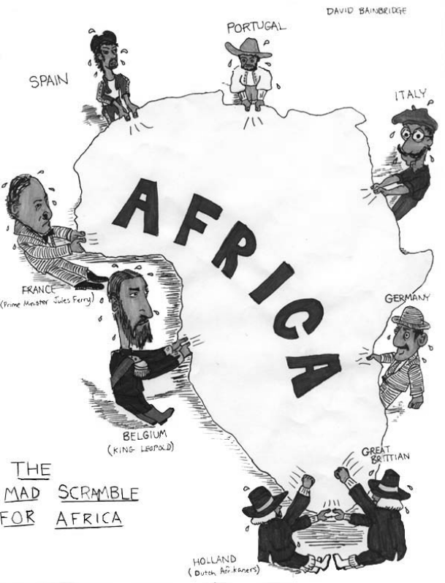

- Who are these people? Where are they from?

- What are they doing?

- Why are they doing what they are doing?

- How do you think the different European countries felt about each other?

- How does this relate to nationalism (intense love and pride for one’s country)?

Source #4: Cartoon of the Berlin Conference

Background: During the Scramble for Africa the Europeans decided that in order to avoid conflicts between each other, they should meet to discuss their claims for land in Africa. At the Berlin Conference (1884/5), the Europeans divided up different parts of Africa amongst themselves. No Africans were present.

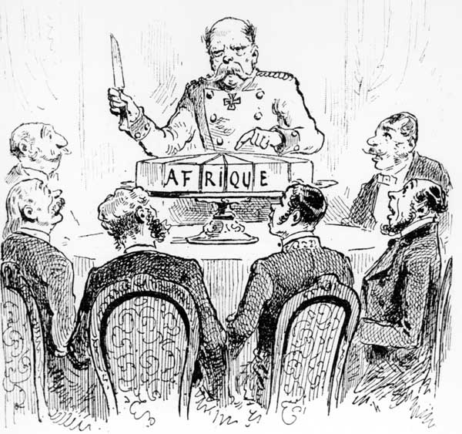

- Summarise the meaning of the cartoon in two sentences or less.

- How did the Berlin Conference influence European imperialism in Africa?

Source #5: The Modern Traveler
Background: This poem was written by a British solider after his army of 50 soldiers beat an African army of 5,000 warriors. He is writing about the Maxim Gun. The Maxim Gun was the first machine gun. It was used against the Africans during imperialism.
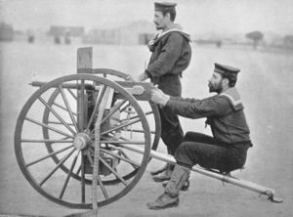
The Modern Traveler

Blood thought he knew the native mind;
He said you must be firm, but kind.
A mutiny resulted.
I shall never forget the way
That Blood stood upon this awful day
Preserved us all from death.
He stood upon a little mound
Cast his lethargic eyes around,
And said beneath his breath:
'Whatever happens, we have got
The Maxim Gun, and they have not.'

Hilaire Belloc, British/French writer and poet.
- Who is “we”?

- Who is “they”?

- Were the Africans able to fight back against the Maxim Gun?

- How did technology impact imperialism?

Source #6: The Benefits of British Rule, 1871, by Dadabhai Naoroji

Benefits of British Rule
In the Cause of Humanity: Abolition of suttee and infanticide
In the Cause of Civilization: Education, both male and female… Resuscitation of India's own noble literature.
Politically: Peace and order. Freedom of speech and liberty of the press. Improvement of government in the native states. Security of life and property. Freedom from oppression…
Materially: Loans for railways and irrigation. Development of a few valuable products, such as indigo, tea, coffee, silk, etc. Increase of exports. Telegraphs.

The Detriments of British Rule
In the Cause of Humanity: Nothing.
In the Cause of Civilization: There has been a failure to do as much as might have been done.
Politically: Repeated breach of pledges to give the natives a fair and reasonable share in the higher administration of their own country……an utter disregard of the feelings and views of the natives.
Financially: New modes of taxation, without any adequate effort to increase the means of the people to pay. Unequal financial relations between England and India.

Summary: To sum up the whole, the British rule has been: Morally - a great blessing; Politically - peace and order on one hand, blunders on the other; Materially - impoverishment….. Our great misfortune is that you do not know our wants. When you will know our real wishes, I have not the least doubt that you would do justice. The genius and spirit of the British people is fair play and justice.
Review: Use a T-chart to compare the costs and benefits of British rule in Africa and India.
Source #7: Letter from African King Lobengula

Background: This letter was written by an African king to Queen Victoria of England.
To Her Majesty Queen Victoria,
“Some time ago, a party of men came to my county, the principal one appearing to be a man called Rudd. They asked me for a place to dig for gold, and said they would give me certain things for the right to do so. I told them to bring what they could give and I would show them what I would give. A document was written and presented to me for signature. I asked what it contained, and was told that in it were my words and the words of those men. I put my hand to it. About three months afterwards I heard from other sources that I had given by the document the right to all the minerals of my country”
Signed: King Lobengula

- What happened to the King’s land?

- How did it happen?

“It is far better to be free to govern or misgovern yourself than to be governed by anybody else.”

“Africa’s earth is rich, yet the products that come from above and below the soil continue to enrich, not Africans, but groups and individuals who operate to Africa’s impoverishment.”

Source #8: Kwame Mkrumah Quotation

Background: Kwame Mkrumah was an African nationalist.
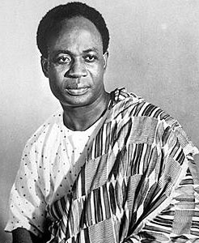
- How did he feel about imperialism? How can you tell?

- Why does he dislike it?

- How does this compare to British imperialism in India?

Obtain: get
Raw Materials: natural resources
Exploit: take advantage of
Surplus: extra
Burden: responsibility
Civilise: educate, to make act correctly
⁷ preserved – kept ⁸ mound – a very small hill ⁹ lethargic – listless, without energy
Humanity – Quality or state of human life
Abolition – The act of doing away with; ending
Suttee – When a woman burns herself alive after her husband’s death.
Infanticide – The practice of killing newborn infants
Civilization - An advanced state of intellectual, cultural, and material development in human society; The act or process of civilizing
Resuscitation - To restore life to
Politically - Dealing with the structure or affairs of government, politics, or the state
Oppression – The act of keeping someone down by severe and unjust use of force or authority
Irrigation - An artificial application of water to the soil usually for assisting in growing crops
Development – Growth or progress, especially economically
Indigo – A blue dye obtained from various plants. It was popular for use in British textiles in the 1800s.
Exports – Items sent out of the country for sale
Telegraphs - A communications system. This was the first machine to enable nearly immediate communication with someone across the world.
Breach – Breaking a promise
Pledge - A solemn promise or agreement to do or refrain from doing something
Utter - Complete; total; absolute
Relations - The various connections between peoples, countries.
Genius – Exception intelligence
Principal: main
Minerals: natural resources in the earth, such as gold, salt, silver, and iron

